# **IT161 LAB REPORT**

# **NAME-ARCHIT AGRAWAL**

# **STUDENT ID-202052307**

# EXPERIMENT-1

## Objective :- write a c programme to calculate sum of 5 subjects and finding its percentage.

Software :- online GCC compiler. Methodology :-

First we have to ask the maximum marks of each subject in the integer format and also marks obtained in each subject in integer format. Now we define sum as integer and store the sum of total obtained marks and define total_marks as integer and we store sum of total maximum marks. Now to define percentage as float and we define percentage as (sum*100/total_marks).

## Algorithm :-

STEP-1:- START

STEP-2:- INPUT MS1,MS2,MS3,MS4,MS5 STEP-3:- INPUT MM1,MM2,MM3,MM4,MM5 STEP-4:- SUM1=MS1+MS2+MS3+MS4+MS5 STEP-5:- SUM2=MM1+MM2+MM3+MM4+MM5 STEP-6:-PERCENTAGE=100*SUM1/SUM2 STEP-7:- PRINT SUM1

STEP-8:- PRINT PERCENTAGE STEP-9:- END

## Flowchart :-

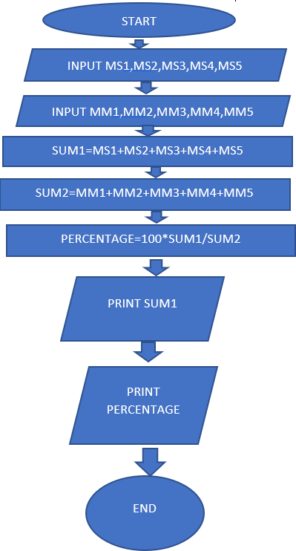

Code :-

#include <stdio.h> int main()

{

int MS1,MS2,MS3,MS4,MS5,MM1,MM2,MM3,MM4,MM5,SUM,TOTAL_MARKS;

float PERCENTAGE;

printf("\nenter maximum marks in the 5 subjects : ");

scanf("%d%d%d%d%d", &MM1,&MM2,&MM3,&MM4,&MM5);

printf("\nenter marks scored in the 5 subjects : ");

scanf("%d%d%d%d%d",&MS1,&MS2,&MS3,&MS4,&MS5);

TOTAL_MARKS = MM1+MM2+MM3+MM4+MM5;

SUM = MS1+MS2+MS3+MS4+MS5;

PERCENTAGE = (SUM*100/TOTAL_MARKS) ;

printf("\n sum of marks obtained is %d", SUM);

printf("\n percentage of marks obtained is %f", PERCENTAGE);

return 0;

}

OUTPUT:

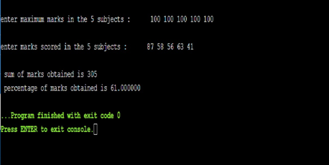

# EXPERIMENT 2:

**Objective** : Program to show swap of two numbers without using a third variable.

**Software** : Visual studio code for c and cpp

**Methodology** : in this program we take two numbers ‘a’ and ‘b’. now we have two swap these numbers. Now the method is we are going to save value of ‘a’ in another variable using ‘a’ and ‘b’. the steps are as follows and let a =10 , b=20

1. a = a + b; //a=30 (10+20)

2. b = a - b; //b=10 (30-20)

3. a = a - b; //a=20 (30-10)

hence the above concept is to swap two number using two variable.

## Flowchart :-

## 

CODE:

#include <stdio.h>

int main()

{

int a , b;

printf("Enter two numbers \n");

scanf("%d%d", &a , &b);

printf("\n Before swapping");

printf("\n Number 1:%d",a);

printf("\n Number 2:%d",b);

a=a+b;

b=a-b;

a=a-b;

printf("\n After swaping");

printf("\n Number 1:%d",a);

printf("\n Number 2:%d",b);

return 0;

}

OUTPUT:

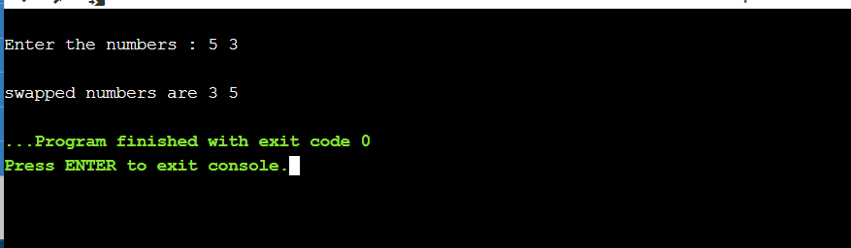

# EXPERIMENT 3:

**Objective** : Program to reverse the digits of a given number.

**Software** : Visual studio code for c and cpp

**Methodology** : here we are going to use while loop for this program. In this program we take ‘n’ as input number and ‘r’ as a variable initiated from r = 0. Step 1- in the first iteration of loop r is multiplied by 10

Step 2- now the value of r is changed to the sum of r and remainder of n when divided by 10

Step 3- now the quotient of n is n/10 and this new value of n is treated as new n in the second iteration of loop.

And so on until the value of become zero.

**Algorithm**

* 1. Declare integer n;
  2. r is initiated from zero;
  3. initiating while with condition n is not equal to zero;
  4. r is replaced by a value r multiplied 10;
  5. again r is replaced by sum of new r and remainder of n when divided by 10;
  6. now n is replaced by quotient of n when divided by 10;
  7. print a and b

Flowchart:

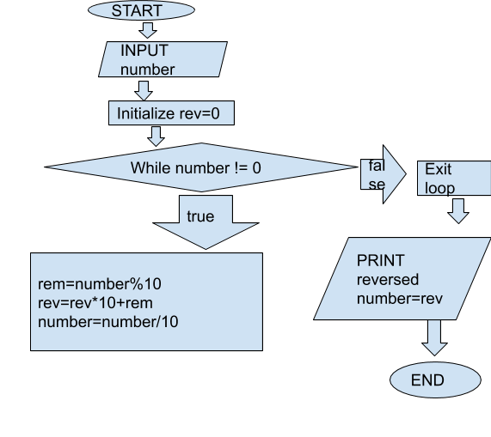

CODE:

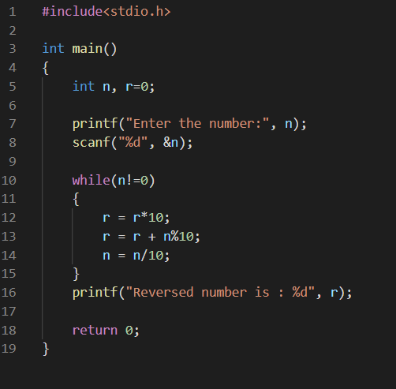

OUTPUT:

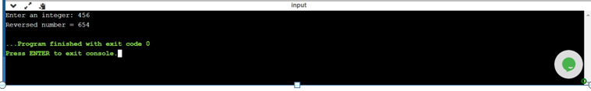

# EXPERIMENT 4:

# **Objective** : Program to print a table of any number

**Software** : Visual studio code for c and cpp

# **Methodology** : here we have to make a program for multiplication table . we are going to do that with while loop.

Here we take input from user end , let the number be ‘n’ and another variable ‘i’ initiated from 1.

Now using while loop with a constrain I is less than or equal to 10.

In first iteration of loop n is multiplied by i and i is post increment by 1. And so on table can be constructed.

**Algorithm**

1. start
2. initialize n and i=1
3. initiating while loop with condition i is less than or equal to 10
4. now i is multiplied by n
5. i get increment of 1
6. print the multiplied number
7. loop get terminated when i = 11

end

|  |  |  |  |  |
| --- | --- | --- | --- | --- |
| Loop 1 | Loop 2 | Loop 3 | Loop 4 | Loop 5 |
| i = 1  n = 10  n*i = 10  i = 1 + 1 = 2 | i = 2  n = 10  n*i = 20  i = 2 + 1 = 3 | i = 3  n = 10  n*i = 30  i = 3 + 1 = 4 | i = 4  n = 10  n*i = 40  i = 4 + 1 = 5 | i = 5  n = 10  n*i = 50  i = 5 + 1 = 6 |
| Loop 6 | Loop 7 | Loop 8 | Loop 9 | Loop 10 |
| i = 6  n = 10  n*i = 60  i = 6 + 1 = 7 | i = 7  n = 10  n*i = 70  i = 7 + 1 = 8 | i = 8  n = 10  n*i = 80  i = 8 + 1 = 9 | i = 9  n = 10  n*i = 90  i = 9 + 1 = 10 | i = 10  n = 10  n*i = 100  i = 10 + 1 = 11 |

CODE:

#include <stdio.h>

int main()

{

int n=1,number,x;

printf("\nenter number : ");

scanf("%d", &number);

printf(“\nenter upto which multiplier you want to print the table : “);

scanf(“%d”,&x);

while( n<= x)

{

printf("\n%d * %d = %d", number,n,number*n);

n=n+1;

}

return (0);

}

OUTPUT:

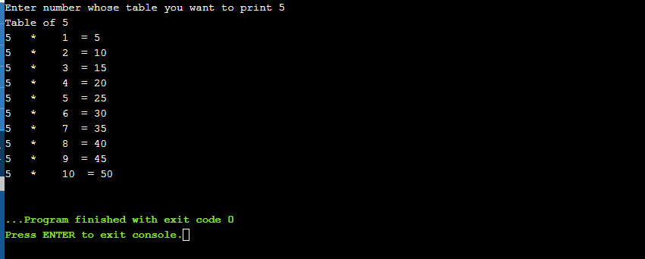

# EXPERIMENT 5:

**Objective** : Program to find the greatest of three numbers.

**Software** : Visual studio code for c and cpp

**Methodology** : in this program we have to find greatest of three number that is input from user end. For this program we are going to use nested if-else statements.

So in this first we take three integer a, b and c.

First take a and compare with b and c, if it is greatest then print a. if a is not greatest then take b and compare with c, if it is greatest print b, if not then print c.

**Algorithm**

1. Start
2. Read the three numbers to be compared, as A, B and C.
3. Check if A is greater than B.
   1. If true, then check if A is greater than C.
      1. If true, print 'A' as the greatest number.
      2. If false, print 'C' as the greatest number.
   2. If false, then check if B is greater than C.
      1. If true, print 'B' as the greatest number.
      2. If false, print 'C' as the greatest number.
4. End

FLOWCHART: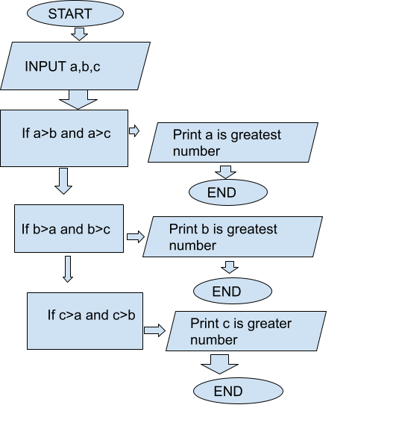

CODE:

#include <stdio.h> int main()

{

int a,b,c;

printf("\nEnter the three numbers : ");

scanf("%d %d %d", &a,&b,&c);

if(a>b && a>c)

printf("\n%d is the largest among three numbers",a); else if(b>a && b>c)

printf("\n%d is the largest among three numbers",b); else if(c>a && c>b)

printf("\n%d is the largest among three numbers",c);

return 0;

}

**OUTPUT:**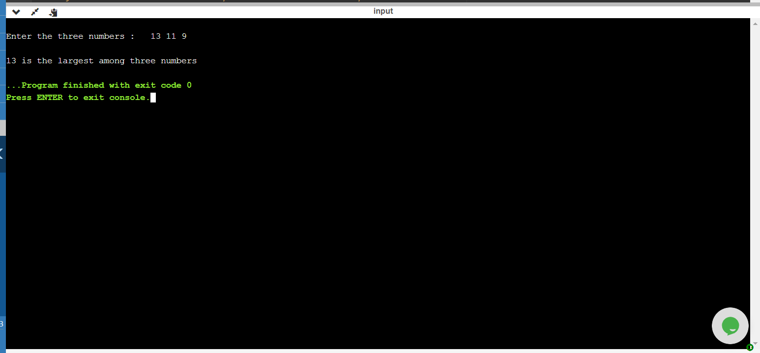

# EXPERIMENT-6

## Objective :-

Write a c programme to find area and circumference of circle

SOFTWARE:Online GCC compiler

CODE:

#include <stdio.h>

int main()

{

float r,c,a,pi;

printf("\nEnter the radius of circle : ");

scanf("%f", &r);

pi=3.14;

a=pi*r*r;

c=2*pi*r;

printf("\nthe value of area of circle is %f", a);

printf("\nthe value of circumference of circle is %f", c);

return 0;

}

OUTPUT:

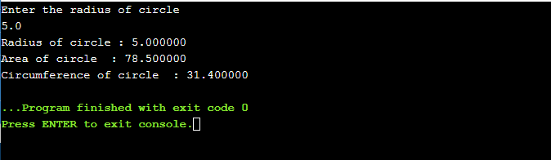

# EXPERIMENT-7

## Objective :-

Write a c programme to convert temperature from centigrade to fahrenheit.

Software :-

Online GCC compiler.

## Algorithm :-

STEP-1:- START

STEP-2:- INPUT CENTIGRADE TEMPERATURE C STEP-3:- F=(9*C/5)+32

STEP-4:- PRINT F STEP-5:- END

CODE:

#include <stdio.h>

int main()

{

float C,F;

printf("\nEnter the temperature in centigrade : ");

scanf("%f", &C);

F=(9*C/5)+32;

printf("\nthe equivalent temperature in fahrenheit is %f", F);

return 0;

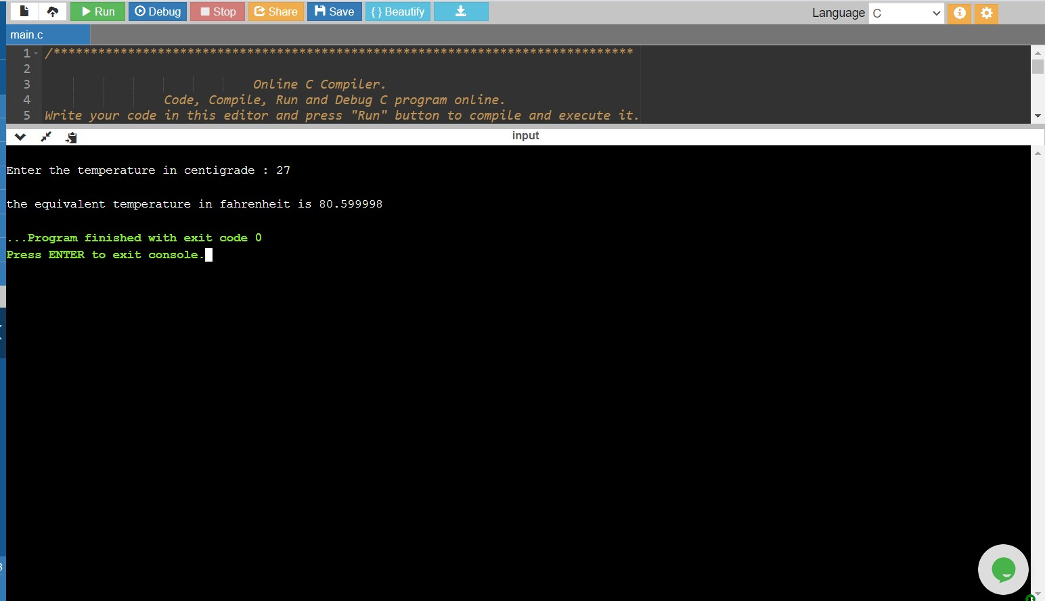}

OUTPUT:

# EXPERIMENT-8

Write a program to find whether the entered year is leap year or not.

DATE OF EXPERIMENT: 6/1/2021

SOFTWARE:

Online Compiler and Debugger for C and C++ (IDE) – C and CPP Compiler

# CODE:

#include <stdio.h>

int main()

{

int yy;

printf("Enter year\n");

scanf("%d",&yy);

if(yy%4==0)

{

if(yy%100==0)

{

if(yy%400==0)

printf(" year %d is a leap year",yy);

else

printf("year %d is not a leap year",yy);

}

else

printf("year %d is a leap year",yy);

}

else

printf( "year %d is not a leap year",yy);

return 0;

}

# OUTPUT:

# 

# EXPERIMENT-9

## Objective :-

Write a c programme to shift input data by two bits to the left.

Software :-

Online GCC compiler

# CODE:

#include <stdio.h> int main()

{

int number;

printf("\nEnter the number : ");

scanf("%d", &number);

number = number << 2;

printf("\nthe shifted number is %d", number);

return 0;

}

OUTPUT:

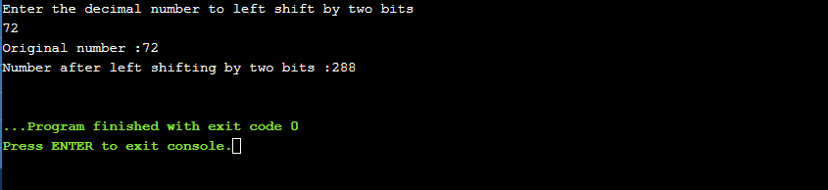

# EXPERIMENT- 10

Write a program to display arithmetic operations on switch case.

SOFTWARE:

Online Compiler and Debugger for C and C++ (IDE) – C and CPP Compiler

CODE:

#include <stdio.h> int main()

{

int num1,num2,operator;

printf("\nselect 1 for addition"); printf("\nselect 2 for subtraction");

printf("\nselect 3 for division"); printf("\nselect 4 for multiplication");

printf("\nEnter the numbers (make sure that number1>number2): ");

scanf("%d %d", &num1,&num2);

printf("\nselect your choice : "); scanf("%d", &operator);

switch(operator)

{

case 1 :

printf("\nsum of %d and %d is %d", num1,num2,num1+num2);

break;

case 2 :

printf("\ndifference of %d and %d is %d", num1,num2,num1-num2);

break;

case 3 :

printf("\ndivision of %d and %d is %d", num1,num2,num1/num2);

break;

case 4 :

printf("\nmultiplication of %d and %d is %d", num1,num2,num1*num2);

break;

default :

printf("\nchoose a correct operator or you might have entered number 2 as 0");

}

return 0;

}

OUTPUT:

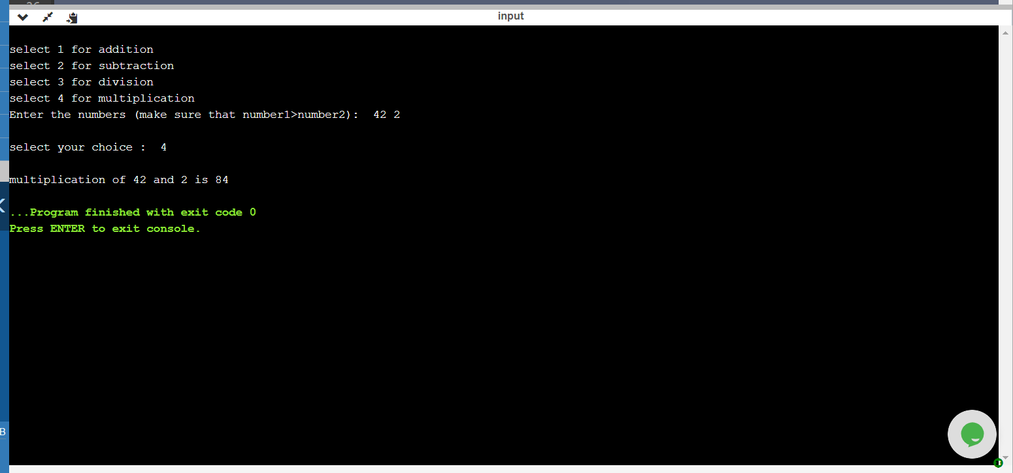

# EXPERIMENT- 11

Write a program to print stars sequence in

1.Right triangle

2.Isosceles triangle

DATE OF EXPERIMENT: 30/12/2020

SOFTWARE:

Online Compiler and Debugger for C and C++ (IDE) – C and CPP Compiler

1.RIGHT TRIANGLE

**CODE:**

#include <stdio.h>

int main()

{

int i,j,n;

printf("Enter number of rows\n");

scanf("%d",&n);

printf("number of rows :%d \n",n);

for(i=1;i<=n;i++)

{

for(j=1;j<=i;j++)

{

printf("* ");

}

printf("\n");

}

return 0;

}

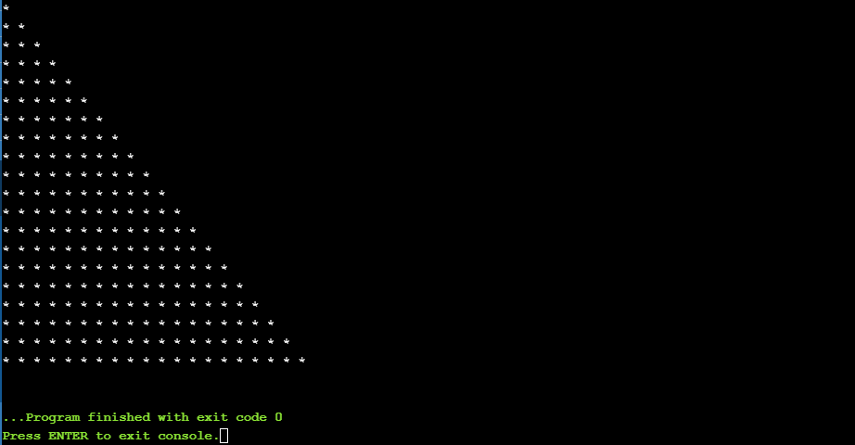

2. ISOSCELES TRIANGLE

**CODE:**

#include <stdio.h>

int main()

{

int i,j,n;

printf("Enter number of rows\n");

scanf("%d",&n);

printf("number of rows: %d \n",n);

for(i=1;i<=n;i++)

{

for(j=1;j<=n-i;j++)

{

printf(" ");

}

for(j=1;j<=i;j++)

{

printf("* ");

}

printf("\n");

}

return 0;

}

**OUTPUT:**

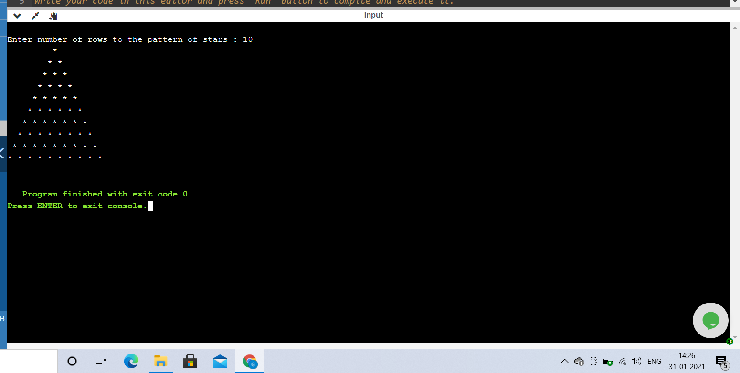

# EXPERIMENT- 12

Write a program to print Fibonacci series upto 100 terms

DATE OF EXPERIMENT: 30/12/2020

SOFTWARE:

Online Compiler and Debugger for C and C++ (IDE) – C and CPP Compiler

**CODE:**

#include <stdio.h>

int main()

{

unsigned long long int i,n,f1=0,f2=1,f3;

printf("Enter number of terms in series\n");

scanf("%llu",&n);

printf("%llu,%llu",f1,f2);

for(i=3;i<=n;i++)

{

f3=f1+f2;

printf(",%llu ",f3);

f1=f2;

f2=f3;

}

return 0;

}

OUTPUT:

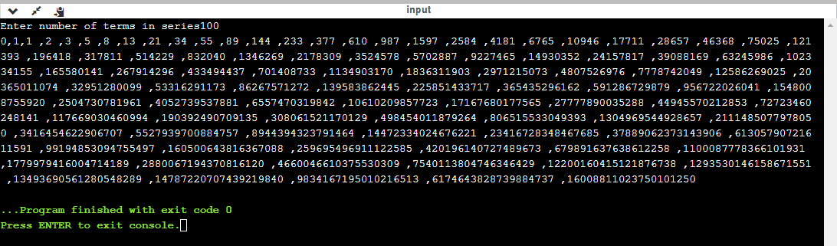

# EXPERIMENT- 13

Write a program to find the factorial of a given number.

DATE OF EXPERIMENT: 30/12/2020

SOFTWARE:

Online Compiler and Debugger for C and C++ (IDE) – C and CPP Compiler

**CODE:**

#include <stdio.h>

int main()

{

int i,num,f=1;

printf("Enter a number\n");

scanf("%d",&num);

for(i=num;i>=1;i--)

{

f=f*i;

}

printf("Factorial of %d is %d",num,f);

return 0;

}

**OUTPUT:**

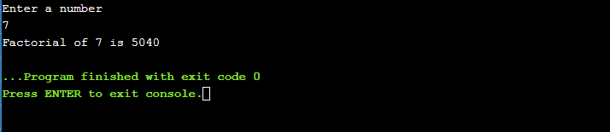

# EXPERIMENT- 14

Write a program to find whether a given number is prime or not.

DATE OF EXPERIMENT: 6/1/2021

SOFTWARE:

Online Compiler and Debugger for C and C++ (IDE) – C and CPP Compiler

**CODE:**

#include <stdio.h>

int main()

{ int n,i,c=0;

printf("Enter a number\n");

scanf("%d",&n);

for(i=2;i<n;i++)

{

if(n%i==0)

c++;

}

if(c==0)

printf("%d is a prime number",n);

else

printf("%d is not a prime number",n);

return 0;

}

**OUTPUT:**

